Dis-Paleo-Eur-England-Anthropomorphic Figurine-Thames-Flint-

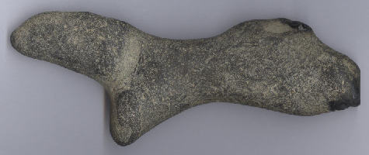 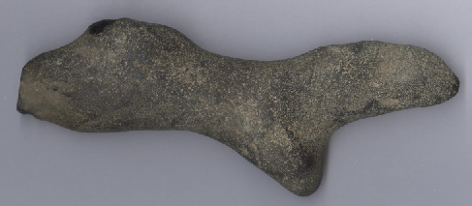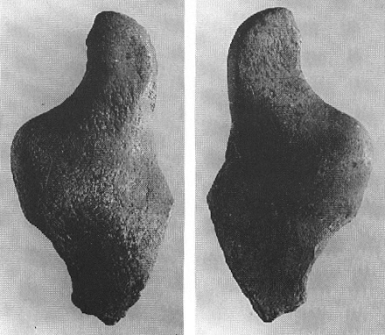

Figs. 1-2: Figs. 3-4

**Case No.: 1**

**Formal Label:**

**Display Description:**

**Accession Number: A1123**

**LC Classification:**

**Date or Time Horizon:**

**Geographical Area:**

**Map, GPS Coordinates:**

**Cultural Affiliation:**

**Medium:**

**Dimensions: H 113.23 mm; 4.461 in;   
Weight:**

**Provenance:**

**Condition:**

**Discussion:**

**References:**

**Sieveking**